

PROJECT FILE

Information Technology

Submitted by-

Arihant Pratap Singh

Submitted to-

Mr. Kapil Sharma Sir

Landing Page

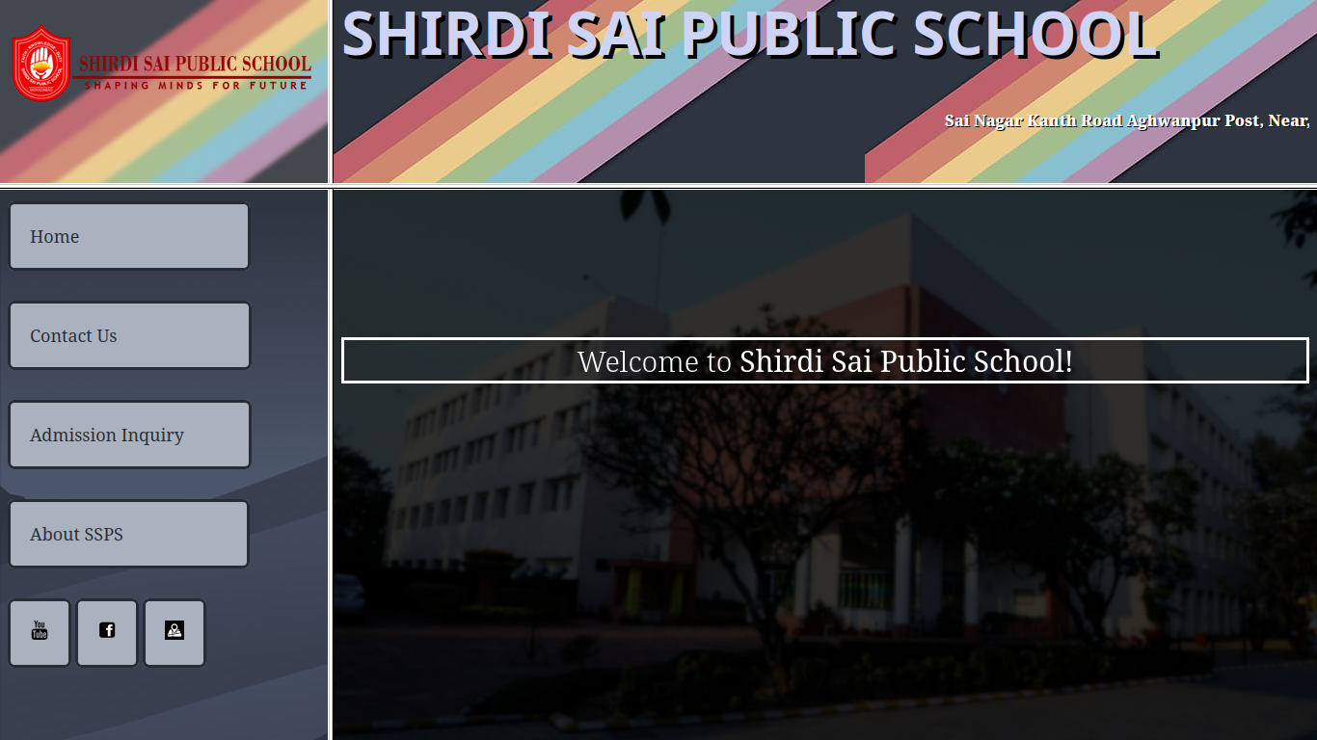

<html>

<frameset rows="25%,*" cols="25%,*">

<frame name="topLeft" src="a.html">

<frame name="topRight" src="b.html">

<frame name="Left" src="c.html">

<frame name="Right" src="d.html">

</frameset>

</html>

| **a.html**  <html>  <head>  <link rel="stylesheet" href="a.css">  </head>  <body background="rainbowbgBLUR.png">  <a href="d.html" target="Right"><img src="sspslogo.png" alt="SSPS"></a>  </body>  </html | **b.html**  <html>  <head>  <link rel="stylesheet" href="b.css">  </head>  <body background="rainbowbg.png">  <h1>SHIRDI SAI PUBLIC SCHOOL</h1>  <marquee>Sai Nagar Kanth Road Aghwanpur Post, Near, Railway Crossing, Moradabad, Uttar Pradesh 244001</marquee>  </body>  </html> |
| --- | --- |
| **a.css**  img{  max-width: 100%;  padding-top: 15px;  } | **b.css**  *{  line-height: 50px;  }  h1{  font-size: 62;  font-weight: 600;  font-family: Verdana, Geneva, Tahoma, sans-serif;  color: rgb(206, 212, 245);  margin-top: 5px;  text-shadow: 4px 4px #000000;  }  marquee{  font-weight: 800;  color: white;  text-shadow: 1px 1px #000000;  } |

| **c.html**  <html>  <head>  <link rel="stylesheet" href="c.css">  </head>  <body background="bluebg.jpg">  <a href="d.html" target="Right">Home  &nbsp;&nbsp;&nbsp;&nbsp;  &nbsp;&nbsp;&nbsp;&nbsp;  &nbsp;&nbsp;&nbsp;&nbsp;  &nbsp;&nbsp;&nbsp;&nbsp;  &nbsp;&nbsp;&nbsp;&nbsp;  &nbsp;&nbsp;&nbsp;&nbsp;  &nbsp;&nbsp;  </a><br><br>  <a href="contactUs.html" target="Right">Contact Us  &nbsp;&nbsp;&nbsp;&nbsp;  &nbsp;&nbsp;&nbsp;&nbsp;  &nbsp;&nbsp;&nbsp;&nbsp;  &nbsp;&nbsp;&nbsp;&nbsp;  &nbsp;&nbsp;&nbsp;&nbsp;</a><br><br>  <a href="admininq.html" target="Right">Admission Inquiry  &nbsp;&nbsp;&nbsp;&nbsp;  &nbsp;&nbsp;&nbsp;&nbsp;</a><br><br>  <a href="aboutus.html" target="Right">About SSPS  &nbsp;&nbsp;&nbsp;&nbsp;  &nbsp;&nbsp;&nbsp;&nbsp;  &nbsp;&nbsp;&nbsp;&nbsp;  &nbsp;&nbsp;&nbsp;&nbsp;  &nbsp;&nbsp;  </a><br><br>  <a href="https://www.youtube.com/channel/UCcKFJF9UFwwZgvE9Rjw_t6g" target=”_blank”><img src="ytlogo.png" width="20" ></a>  <a href="https://www.facebook.com/shirdisaipublicschools/" target=”_blank”><img src="fblogo.png" width="20"></a>  <a href="https://g.page/shirdi-sai-public-school?share" target=”_blank”><img src="gmapslogo.png" width="20"></a>  </body>  </html> | **d.html**  <html>  <head>  <link rel="stylesheet" href="d.css">  </head>  <body>  <br><br><br><br><br>  <center><p>Welcome to <b>Shirdi Sai Public School!</b></p></center>  </body>  </html> |
| --- | --- |
| **c.css**  *{  align-items: center;  }  a{  color: #282c34;  text-decoration: none;  font-size: large;  line-height: 80px;  border-style: solid;  padding: 20px;  background-color: #abb2bf;  border-radius: 7px;  } | **d.css**  body {  background-image: url("SSPSmoradabad.png");  height: 100%;  background-position: center;  background-repeat: no-repeat;  background-size: cover;  }  p{  font-size: 30px;  color: white;  border: solid;  font-weight: 300;  } |

Contact Us Page

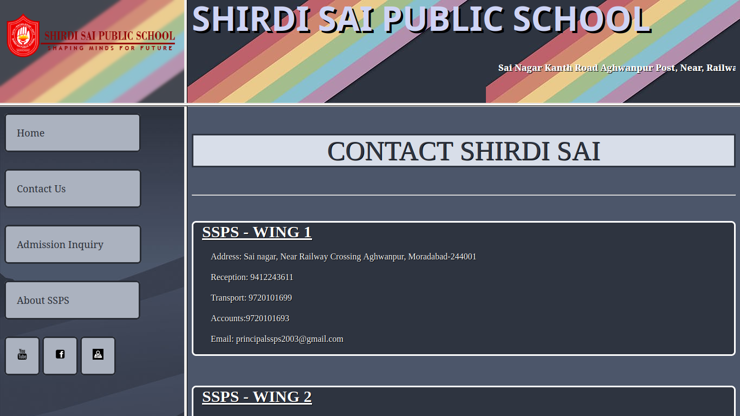

| **contactUs.html**  <html>  <head>  <link rel="stylesheet" href="contactUs.css">  </head>  <body>  <center><p>CONTACT SHIRDI SAI</p></center><hr><br>  <pre>  <b>SSPS - WING 1</b>    Address: Sai nagar, Near Railway Crossing Aghwanpur, Moradabad-244001    Reception: 9412243611    Transport: 9720101699    Accounts:9720101693    Email: principalssps2003@gmail.com  </pre>  <br>  <pre>  <b>SSPS - WING 2</b>  Address: Sai nagar, Near Railway Crossing Aghwanpur, Moradabad-244001    Reception: 9720101694    Transport: 9720101699    Accounts:9720101693  Email: principalwing2@shirdisaipublicschool.com  </pre>  <br><br><hr><br><br>  </body>  </html> | **contactUs.css**  *{  background-color: #4c566a;  color: white;  text-shadow: 1px 1px black;  }  b{  font-family: 'Times New Roman';  text-decoration: underline;  font-size: 30px;  background-color: #2e3440;  }  pre{  border: solid;  font-family: 'Times New Roman';  background-color: #2e3440;  border-radius: 8px;  }  h1{  font-family: monospace;  font-size: 50px;  }  p{  color: #2e3440;  font-size: 50;  font-family: 'Times New Roman';  font-weight: 400;  border: solid;  background-color: #d8dee9;  } |
| --- | --- |

Admission Inquiry Page

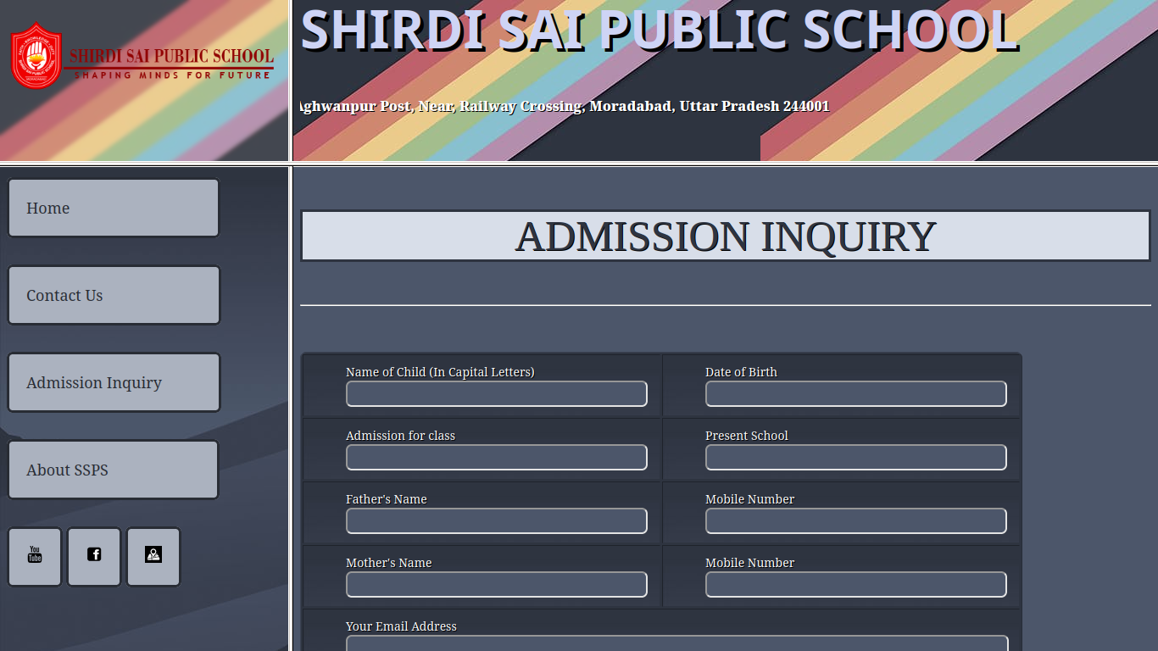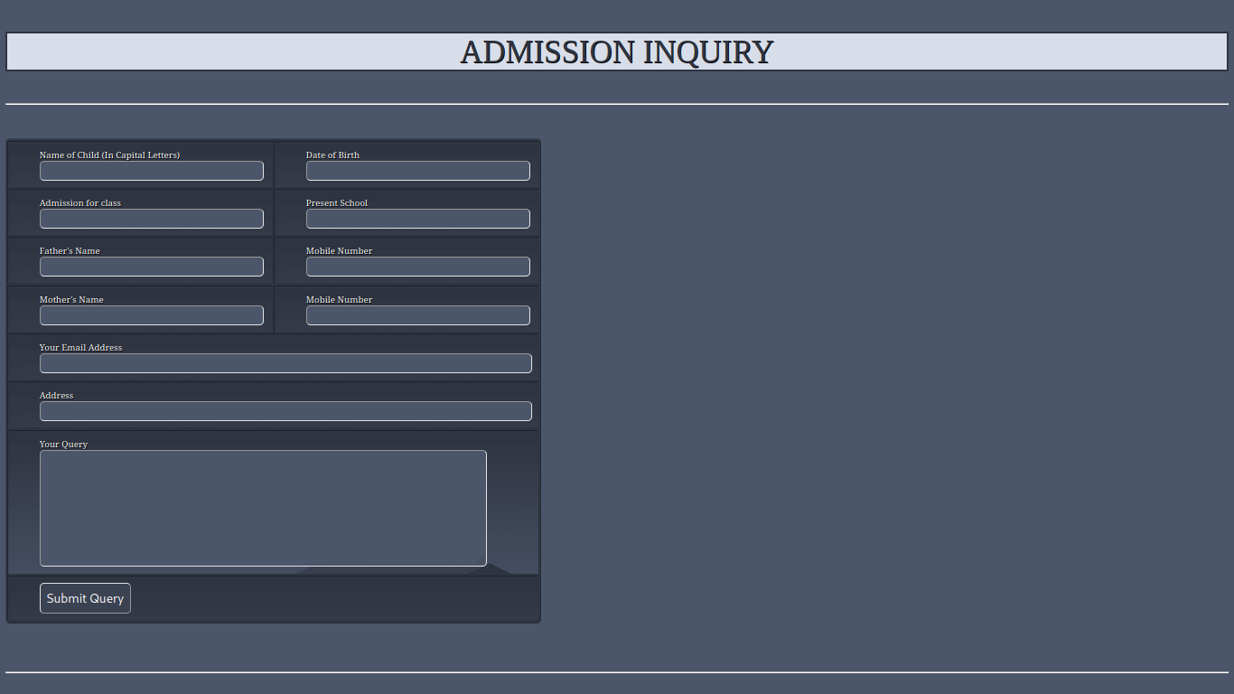

| **admininq.html**  <html>  <head>  <link rel="stylesheet" href="admininq.css">  </head>  <body>  <center><p>ADMISSION INQUIRY</p></center><hr>  <table border="black">  <tr><td>Name of Child (In Capital Letters)<br><input type="text" size="40"></td>  <td>Date of Birth <br> <input type="text" size="40"></td>  </tr>  <tr>  <td>Admission for class <br> <input type="text" size="40"></td>  <td>Present School <br> <input type="text" size="40"></td>  </tr>  <tr>  <td>Father's Name <br><input type="text" size="40"></td>  <td>Mobile Number <br><input type="text" size="40"></td>  </tr>  <tr>  <td>Mother's Name <br><input type="text" size="40"></td>  <td>Mobile Number <br><input type="text" size="40"></td>  </tr>  <tr><td colspan="2">Your Email Address<br><input type="text" size="92"></td></tr><br>  <tr><td colspan="2">Address <br><input type="text" size="92"></td></tr><br>  <tr><td colspan="2">Your Query <br> <textarea cols="94" rows="10"></textarea></td></tr>  <tr><td colspan="2"><button type="submit">Submit Query</button></td></tr>  </table>  <br>  &nbsp;&nbsp;&nbsp;&nbsp;  <br><br><hr><br><br>  </body>  </html> | **admininq.css**  *{  background-color: #4c566a;  text-shadow: 1px 1px black;  color: white;  }  p{  color: #2e3440;  font-size: 50;  font-family: 'Times New Roman';  font-weight: 400;  border: solid;  background-color: #d8dee9;  }  td{  padding: 10px;  padding-left: 50px;  font-size: 14;  background-image: url(bluebg.jpg);  border-color: #2e3440;  }  input{  padding: 5px;  border-radius: 7px;  }  textarea{  padding: 5px;  border-radius: 7px;  }  button{  font-size: 20;  padding: 10px;  border-radius: 7px;  color: white;  background-color: #3b4252;  text-shadow: none;  }  table{  border-radius: 8px;  background-color: #2e3440;  color: #3b4252;  } |
| --- | --- |

About SSPS Page

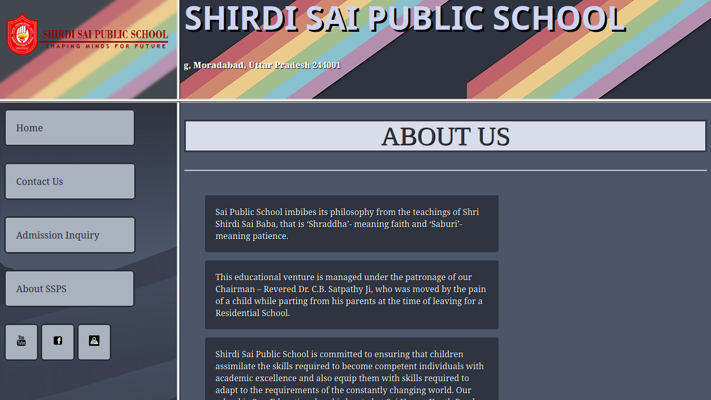

| **aboutus.html**  <html>  <head>  <link rel="stylesheet" href="aboutus.css">  </head>  <body>    <center><h1>ABOUT US</h1></center>  <hr><br>  <p>Sai Public School imbibes its philosophy from the teachings of Shri Shirdi Sai Baba, that is ‘Shraddha’- meaning faith and ‘Saburi’- meaning patience. </p>  <p>This educational venture is managed under the patronage of our Chairman – Revered Dr. C.B. Satpathy Ji, who was moved by the pain of a child while parting from his parents at the time of leaving for a Residential School.</p>  <p>Shirdi Sai Public School is committed to ensuring that children assimilate the skills required to become competent individuals with academic excellence and also equip them with skills required to adapt to the requirements of the constantly changing world. Our school is Co – Educational and is located at Sai Nagar; Kanth Road, Moradabad.</p>  <p>One of its kind, our school aims at providing a nurturing environment and groom our students to respect nature, be conscientious in using natural resources, develop a positive attitude towards life, sportsmanship and confidence. </p>  <p>Our curriculum is based on the guidelines from Central Board of Secondary Education (CBSE). We also incorporate a spectrum of co-curricular and extra-curricular activities into the schedule so as to assist the development of your child.</p>  <p>For pre-schoolers, these activities include fine motor and gross motor activities. For older children, activities include Performing Arts, Fine Arts, Sports, Theatre, Story Telling, Project Based Learning, Sewa projects, IT based projects & programs, Beyond Classroom initiatives etc. The student-teacher ratio is low to enable individual care & attention for your child. We provide a ‘Uniform system of assessment, examination and report card’ which is aimed at standardizing teaching and evaluation across the entire school, as per the directives/ guidelines of the CBSE.</p>  <br><br><hr><br><br>  </body>  </html> | **aboutus.css**  *{  background-color: #4c566a;  color: white;  text-shadow: 1px 1px black;  }  h1{  color: #2e3440;  font-size: 50;  font-family: 'Times New Roman';  font-weight: 400;  border: solid;  background-color: #d8dee9;  }  p{  margin-right: 400px;  margin-left: 40px;  background-color: #2e3440;  padding: 20px;  border-radius: 4px;  } |
| --- | --- |